WEEK 03 MODULE
Programming Practice
TOPIC : 1 QUICK SORT
b) Medium

que. 2 What is Sorting?

- Sorting is the technique of arranging data elements in a particular order according to a chosen criterion, such as numerical value, alphabetical order, or date.

Types of Sorting :-
- Bubble Sort
- Selection Sort
- Insertion Sort
- Merge Sort
- Quick Sort
- Heap Sort

Quick Sort
Definition : Quick Sort is a Divide and Conquer sorting algorithm.
- Choose a pivot element.
- Rearrange the array so that:
  - Elements smaller than the pivot go to the left.
  - Elements greater than the pivot go to the right.
- Repeat the same process for the left and right subarrays until the entire array is sorted.

Key Points:-
- Uses Divide and Conquer.
- Selects a pivot element.
- Partitions the array around the pivot.
- Recursively sorts the left and right subarrays.
- In-place sorting algorithm (requires very little extra memory).
- Average Time Complexity: O(n log n).
- Worst Case Time Complexity: O(n²) (when poor pivots are repeatedly chosen).

How It Works:-
38 27 43 3 9 82 10
Choose Pivot = 38
27 3 9 10 | 38 | 43 82
↓
Sort left part → 3 9 10 27
Sort right part → 43 82
↓
3 9 10 27 38 43 82

Problem Statement
A financial analytics company receives daily trade-value data from multiple stock exchanges. Analysts
use this information to identify high-value trading activity and market trends.
The trade values are received in random order throughout the day. Before analysis can begin, the
data must be sorted in descending order.
Your task is to implement Quick Sort to arrange the trade values from highest to lowest.
After sorting, perform the following operations:

1. Display the sorted trade values.
2. Find the Top 5 highest trade values.
3. Calculate the average of the Top 5 values.
4. Count how many trade values are greater than the overall average of all trade values.
This problem evaluates your understanding of partitioning, recursion, and real-world data analysis
using Quick Sort.

1. Question Analysis
A financial analytics company receives daily trade-value data from multiple stock exchanges in random order. To analyze high-value trading activity and identify market trends, the trade values must first be arranged in descending order. After sorting, the analysts need to identify the Top 5 highest trade values, calculate the average of these Top 5 values, and determine how many trade values are greater than the overall average of all trade values.
Since a large amount of trading data is processed every day, an efficient sorting algorithm is required. Therefore, the task is to implement the Quick Sort algorithm to sort the trade values in descending order without using any built-in sorting methods.

2. Problem Analysis
The given problem requires sorting an unsorted list of trade values in descending order using the Quick Sort algorithm. Since the financial analytics company receives trading data from multiple stock exchanges, the sorting technique should efficiently handle large datasets while maintaining good performance.
Quick Sort solves this problem by selecting a pivot element, partitioning the array into two parts based on the pivot, and recursively sorting each partition until the entire array is arranged in descending order. After sorting, the Top 5 highest trade values are identified, their average is calculated, and the overall average of all trade values is used to count the number of trade values that are greater than it. These operations help analysts identify significant trading activities and study market trends.

3. Algorithm Selection Analysis
Selected Algorithm: Quick Sort
- Quick Sort follows the Divide and Conquer technique.
- It selects a pivot element and partitions the array around it.
- It recursively sorts the left and right partitions until the entire array is sorted.
- It efficiently handles large datasets containing thousands of trade values.
- The sorted array makes it easy to identify the Top 5 highest trade values and perform further statistical analysis.
- It performs sorting in-place, requiring very little extra memory.

4. Points to Remember
- Quick Sort follows the Divide and Conquer technique.
- A pivot element is selected during each recursive call.
- The array is partitioned so that elements greater than the pivot are placed on one side and smaller elements on the other.
- This problem requires descending order, so larger trade values are placed before smaller trade values.
- The partitioning and recursive process continues until the entire array becomes sorted.

- After sorting, the Top 5 highest trade values are obtained from the beginning of the sorted array.
- The average of the Top 5 values is calculated.
- The overall average of all trade values is calculated.
- The number of trade values greater than the overall average is determined.
- Time Complexity
  - Best Case : O(N log N)
  - Average Case : O(N log N)
  - Worst Case : O(N²)
- Space Complexity : O(log N) (due to recursive call stack)

5. Core Idea / Logic
- Select the last element of the current subarray as the pivot.
- Partition the array so that trade values greater than the pivot are placed on the left and smaller values on the right.
- Recursively apply Quick Sort to the left and right partitions until the complete array is sorted in descending order.
- Display the sorted trade values.
- Select the first five elements of the sorted array as the Top 5 highest trade values.
- Calculate the average of the Top 5 trade values.
- Calculate the overall average of all trade values.
- Count the number of trade values greater than the overall average.
- Display all the required results.

6. Execution Flow

Part A : Execution Flow

Input Phase
- The program starts execution from the main() method.
- The user enters the number of trade values (N).
- The program validates whether N is within the specified range.
- An array of size N is created to store the trade values.
- The user enters all trade values.
- Each trade value is validated and stored in the array.
- The quickSort() method is called to sort the trade values in descending order.

Processing Phase
- The quickSort() method selects the last element of the current subarray as the pivot.
- The partition() method rearranges the trade values such that values greater than the pivot are placed on the left and smaller values on the right.
- The pivot is placed at its correct position in the descending order.
- The quickSort() method is recursively called for the left and right partitions until the complete array becomes sorted.
- The first five elements of the sorted array are identified as the Top 5 highest trade values.
- The average of the Top 5 trade values is calculated.
- The overall average of all trade values is calculated.
- The number of trade values greater than the overall average is counted.

Output Phase
- Control returns to the main() method.

- The sorted trade values are displayed in descending order.
- The Top 5 highest trade values are displayed.
- The average of the Top 5 trade values is displayed.
- The count of trade values greater than the overall average is displayed.
- The program terminates successfully.

Part B : Steps
Step 1: Start the execution of the program.
Step 2: Read the number of trade values (N) from the user.
Step 3: Validate the value of N. If N is less than 5 or greater than 100000, display an error message and terminate the program.
Step 4: Create an array of size N to store the trade values.
Step 5: Read each trade value from the user, validate that every value lies between 1 and 1000000000, store the valid values in the array, and simultaneously calculate the total sum of all trade values.
Step 6: Call the quickSort(arr, 0, n - 1) method to sort the trade values in descending order.
Step 7: Select the last element of the current subarray as the pivot and partition the array so that all trade values greater than or equal to the pivot are placed on the left and the remaining values are placed on the right.
Step 8: Place the pivot at its correct position and recursively apply Quick Sort to the left and right partitions until the complete array becomes sorted in descending order.
Step 9: Display the sorted trade values.
Step 10: Select the first five elements of the sorted array as the Top 5 highest trade values and calculate their total.
Step 11: Divide the total of the Top 5 trade values by 5 to calculate the average of the Top 5 values.
Step 12: Calculate the overall average of all trade values by dividing the total sum of all trade values by N.
Step 13: Traverse the sorted array and count the number of trade values that are greater than the overall average.
Step 14: Display the Top 5 trade values, their average, and the number of trade values greater than the overall average.
Step 15: Close the Scanner object and terminate the program.

7. Program Structure Analysis

i. Variable n
int n;
Purpose:
- Stores the total number of trade values entered by the user.
- Determines the size of the array.
- Defines the number of trade values to be sorted.

- Constraint:
5 ≤ n ≤ 100000
- Minimum value of n can be 5.
- Maximum value of n can be 100000.

ii. Array arr[]
long[] arr = new long[n];
Purpose:
- Stores all trade values entered by the user.
- Acts as the main array on which Quick Sort is performed.
- Stores the trade values in descending order after sorting is completed.
- Constraint:
1 ≤ Trade Value ≤ 10⁹
- Minimum trade value can be 1.
- Maximum trade value can be 1000000000.

iii. Variable pivot
long pivot = arr[high];
Purpose:
- Stores the pivot element selected for partitioning.
- Uses the last element of the current subarray as the pivot.
- Helps divide the array into two partitions during Quick Sort.

iv. Variables low, high and pivotIndex
quickSort(arr, low, high);
int pivotIndex;
Purpose:
- low represents the starting index of the current subarray.
- high represents the ending index of the current subarray.
- pivotIndex stores the final position of the pivot after partitioning.
- These variables control the recursive sorting process.

v. Variables i and j
int i = low - 1;
for(int j = low; j < high; j++)
Purpose:
- i keeps track of the position where the next larger trade value should be placed.
- j traverses the current subarray and compares each element with the pivot.
- Together, they help partition the array in descending order.

vi. Variable temp
long temp;
Purpose:
- Temporarily stores an element during swapping.
- Prevents data loss while exchanging the positions of two trade values.

vii. Variable totalSum
long totalSum = 0;
Purpose:
- Stores the sum of all trade values entered by the user.
- Used to calculate the overall average of all trade values.
- Is updated while reading the input values.

viii. Variable top5Sum
long top5Sum = 0;
Purpose:
- Stores the sum of the Top 5 highest trade values.
- Used to calculate the average of the Top 5 trade values after sorting.

ix. Variable top5Average
double top5Average = top5Sum / 5.0;
Purpose:
- Stores the average of the Top 5 highest trade values.
- Uses 5.0 to perform floating-point division for accurate results.

x. Variable overallAverage
double overallAverage = totalSum / (double)n;
Purpose:
- Stores the average of all trade values entered by the user.
- Acts as the reference value for counting trade values greater than the average.

xi. Variable count
int count = 0;
Purpose:
- Counts the number of trade values that are greater than the overall average.
- Increases whenever a trade value satisfies the required condition.

xii. Input Loop
for(int i = 0; i < n; i++)
{
arr[i] = sc.nextLong();
}
Purpose:
- Accepts all trade values from the user.
- Validates every trade value according to the given constraints.
- Stores the values in the array.
- Simultaneously calculates the total sum of all trade values.

xiii. quickSort() Method
quickSort(arr, low, high);
Purpose:
- Recursively sorts the array in descending order.
- Calls the partition() method to position the pivot correctly.
- Continues sorting the left and right partitions until the complete array becomes sorted.

xiv. partition() Method
partition(arr, low, high);
Purpose:
- Selects the pivot element.
- Rearranges the elements so that larger values are placed before the pivot and smaller values after it.
- Returns the final position of the pivot.
- Forms the basis of the Quick Sort algorithm.

xv. Partition Loop
for(int j = low; j < high; j++)
Purpose:
- Traverses the current subarray.
- Compares every trade value with the pivot.
- Swaps elements whenever a larger trade value is found.
- Helps partition the array in descending order.

xvi. Top 5 Loop
for(int i = 0; i < 5; i++)
Purpose:
- Traverses the first five elements of the sorted array.
- Displays the Top 5 highest trade values.
- Simultaneously calculates their total.

xvii. Count Loop
for(int i = 0; i < n; i++)
Purpose:
- Traverses the sorted array.
- Compares every trade value with the overall average.
- Counts the number of trade values greater than the overall average.

xviii. Output Loop
for(int i = 0; i < n; i++)
{
System.out.print(arr[i] + " ");
}
Purpose:
- Traverses the sorted array.
- Displays all trade values in descending order.
- Produces the final sorted output before displaying the calculated statistical information.

8. Java Program
package week3_module;
import java.util.Scanner;
public class QuickSortMedium {
// Partition function for descending order
static int partition(long[] arr, int low, int high) {
long pivot = arr[high];
int i = low - 1;
for (int j = low; j < high; j++) {
// Arrange in descending order
if (arr[j] >= pivot) {
i++;
long temp = arr[i];
arr[i] = arr[j];
arr[j] = temp;
}
}
long temp = arr[i + 1];
arr[i + 1] = arr[high];
arr[high] = temp;
return i + 1;
}
// Recursive Quick Sort
static void quickSort(long[] arr, int low, int high) {

if (low < high) {
int pivotIndex = partition(arr, low, high);
quickSort(arr, low, pivotIndex - 1);
quickSort(arr, pivotIndex + 1, high);
}
}
public static void main(String[] args) {
Scanner sc = new Scanner(System.in);
System.out.print("Enter the number of trade values : ");
int n = sc.nextInt();
if (n < 5 || n > 100000) {
System.out.println("Error: N must be between 5 and 100000.");
sc.close();
return;
}
long[] arr = new long[n];
long totalSum = 0;
System.out.print("Enter the trade values : ");
for (int i = 0; i < n; i++) {
arr[i] = sc.nextLong();
if (arr[i] < 1 || arr[i] > 1000000000L) {
System.out.println("Error: Trade value must be between 1 and 1000000000.");
sc.close();
return;
}
totalSum += arr[i];
}
// Perform Quick Sort
quickSort(arr, 0, n - 1);
// Display sorted trade values
System.out.print("Sorted Trade Values : ");
for (int i = 0; i < n; i++) {
System.out.print(arr[i] + " ");
}
System.out.println();
// Display Top 5 values
System.out.print("Top 5: ");
long top5Sum = 0;
for (int i = 0; i < 5; i++) {
System.out.print(arr[i] + " ");
top5Sum += arr[i];
}
System.out.println();
// Average of Top 5

double top5Average = top5Sum / 5.0;
System.out.println("Average of Top 5: " + top5Average);
// Overall average
double overallAverage = totalSum / (double) n;
// Count values above overall average
int count = 0;
for (int i = 0; i < n; i++) {
if (arr[i] > overallAverage) {
count++;
}
}
System.out.println("Values Above Overall Average: " + count);
sc.close();
}
}
NOTE:- The constraint is: 1 ≤ Trade Value ≤ 10^9
A single trade value fits in an int, but when adding thousands of trade values, the total sum can easily exceed the maximum value an int can hold (2,147,483,647). Using long for the array values and the sum prevents integer overflow and makes the program safe for the given constraints.
- Program’s output
Enter the number of trade values : 8

Enter the trade values : 500 1200 700 2000 900 1500 3000 2500
Sorted Trade Values : 3000 2500 2000 1500 1200 900 700 500
Top 5: 3000 2500 2000 1500 1200
Average of Top 5: 2040.0
Values Above Overall Average: 3
- Screenshot
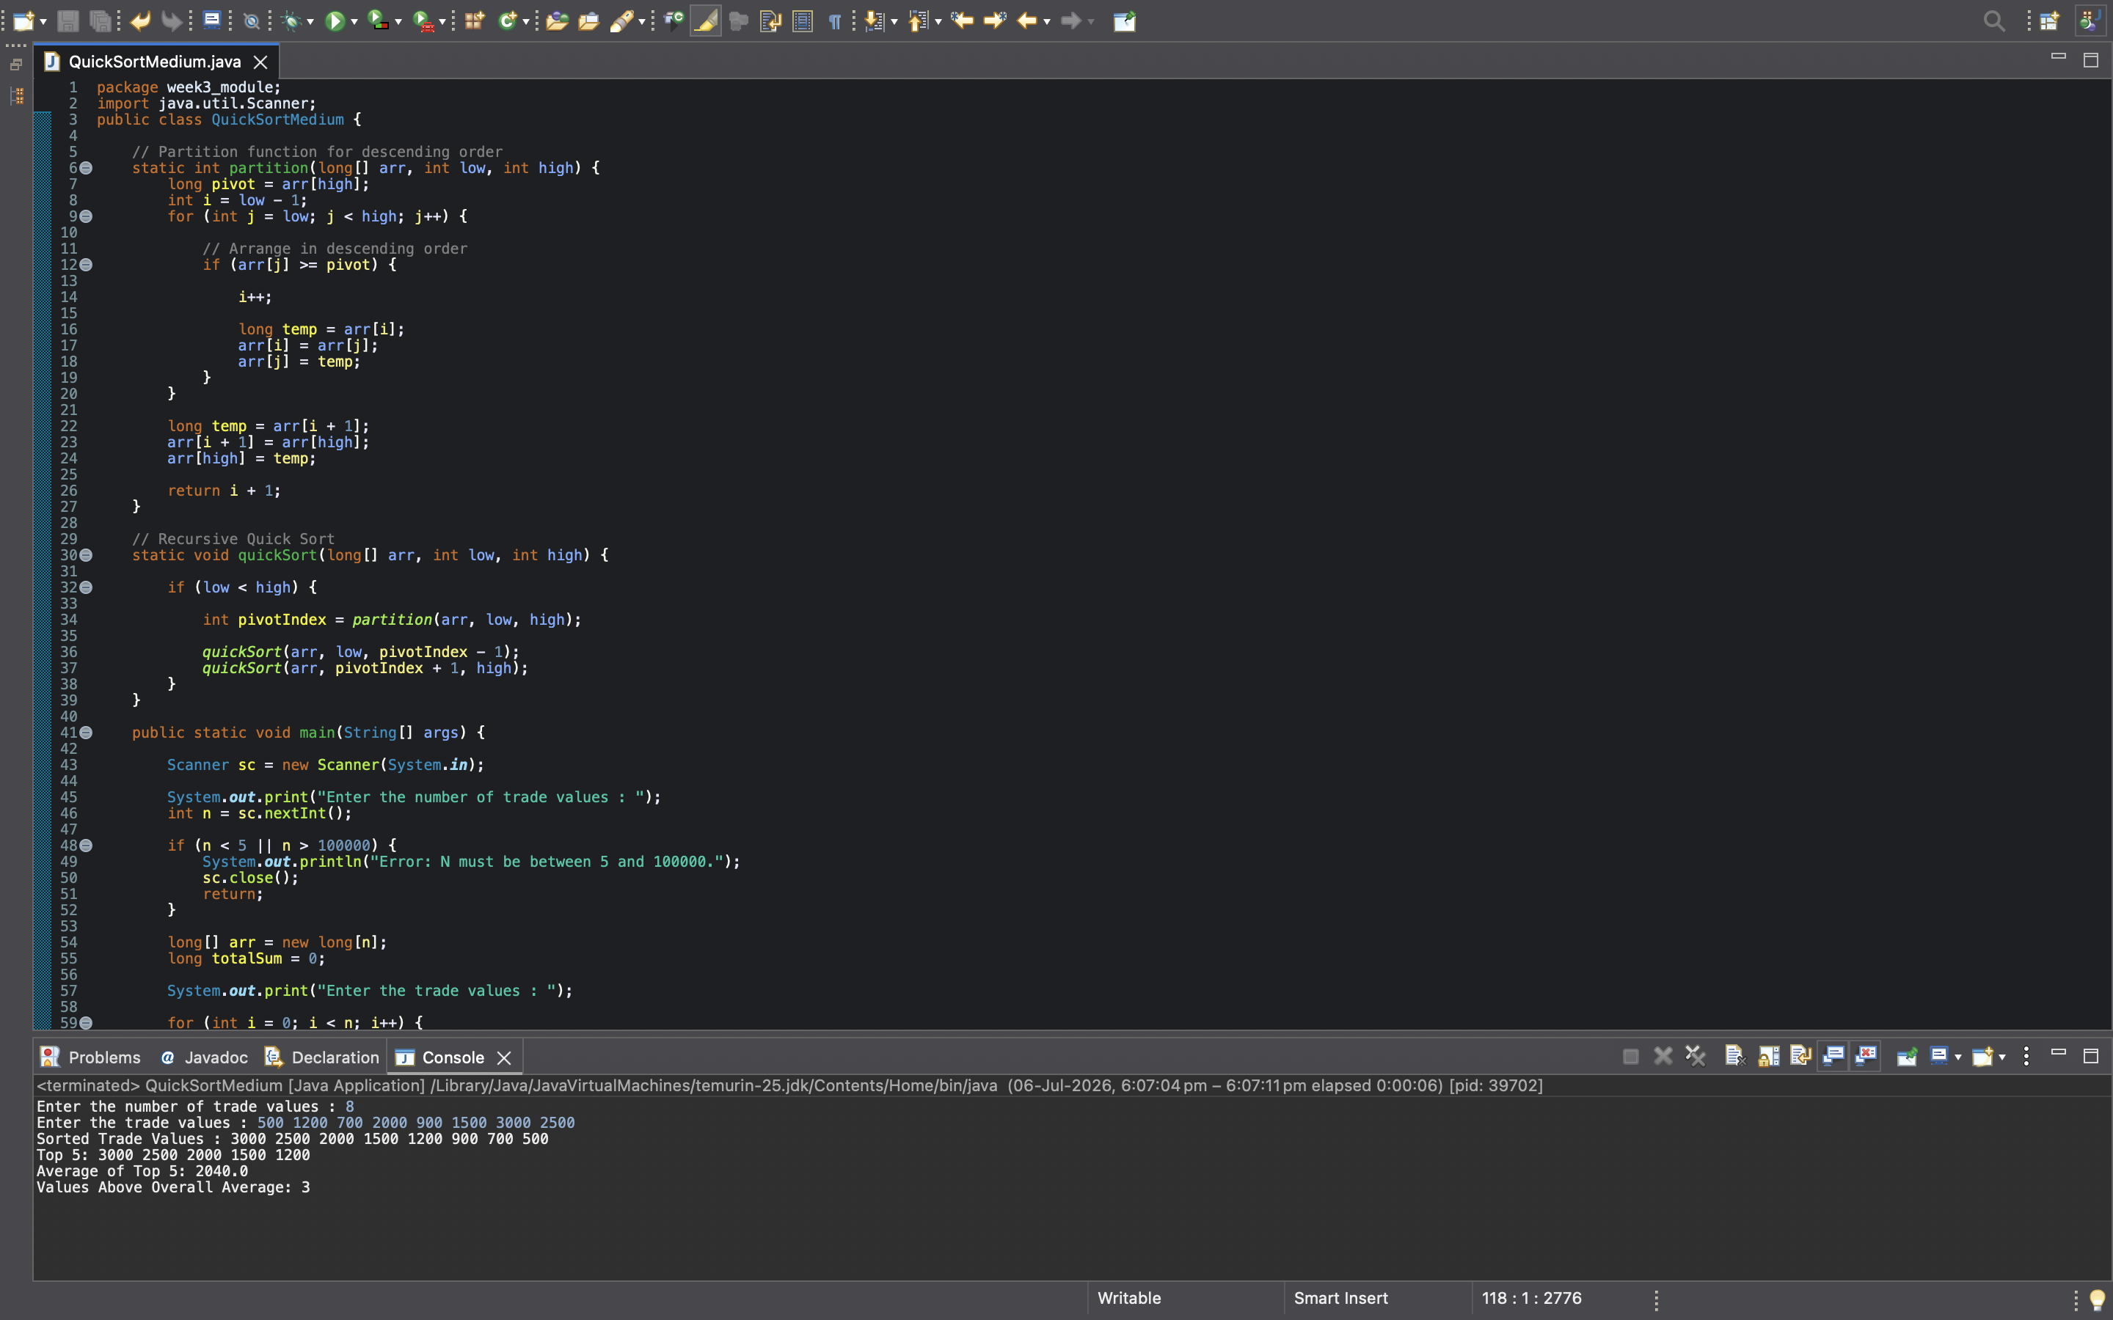
Program



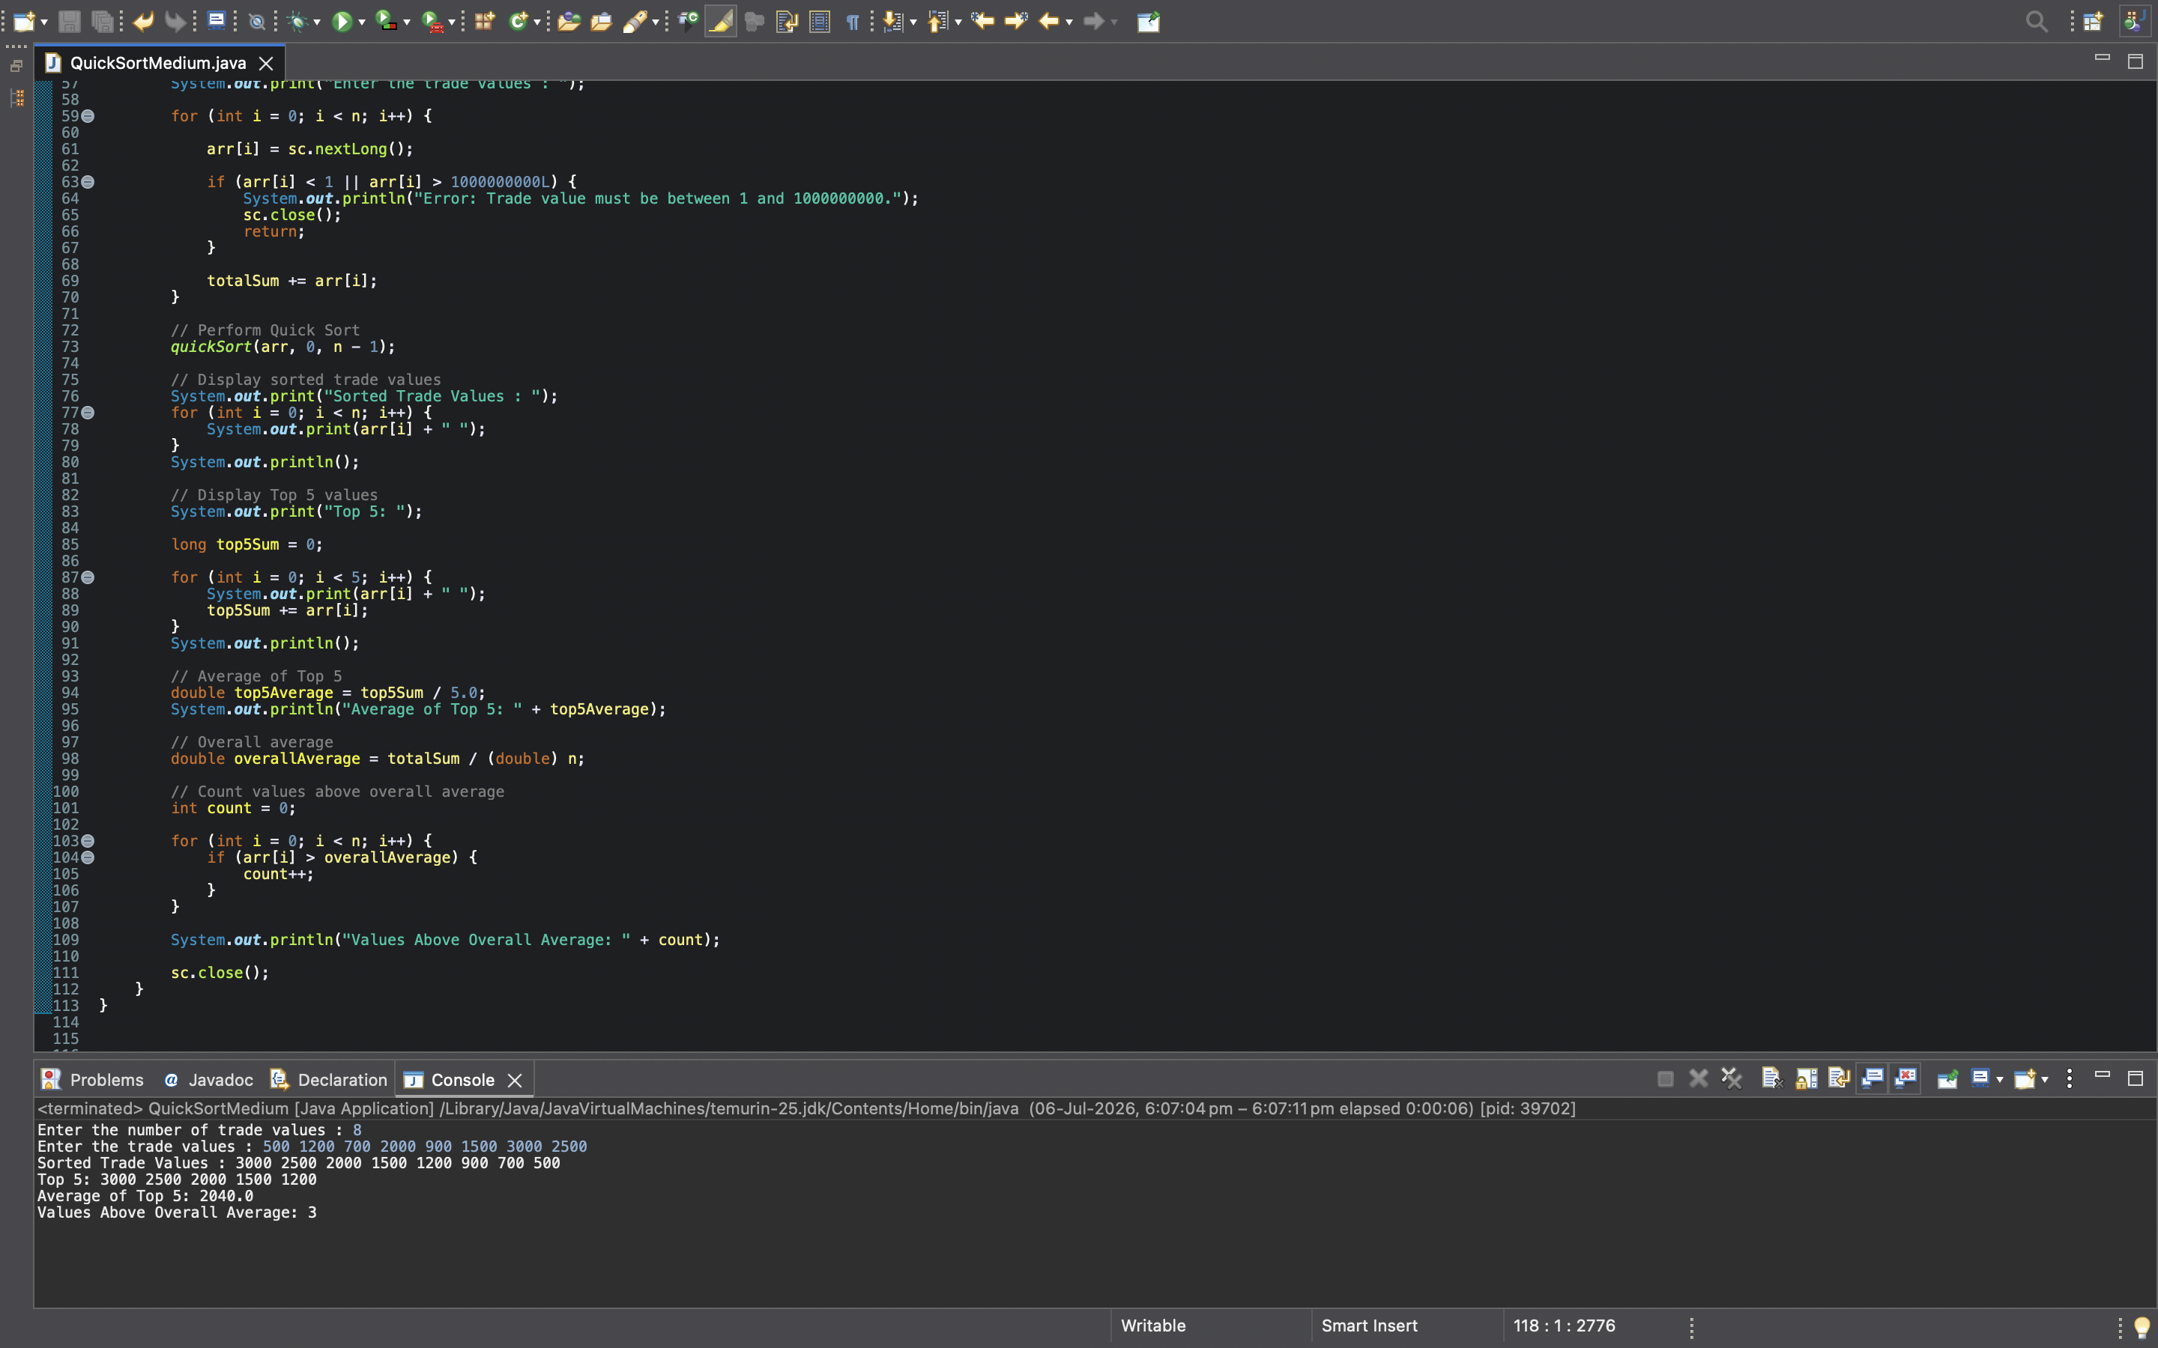

Program’s output


- EXPLANTAION
Every day, different stock exchanges send trade values.
Example: 500 1200 700 2000 900 1500 3000 2500
These numbers represent the value of different trades.
But they're completely random.
The analyst says,
"Arrange them from highest to lowest.
Then tell me:
- the Top 5 trade values,
- their average,
- and how many trades are above the overall average."
That's exactly what this program does.

STEP 1 — main() starts
public static void main(String[] args)
Every Java program starts here.

STEP 2 — Scanner
Scanner sc = new Scanner(System.in);

STEP 3 — Read N
int n = sc.nextInt();
Suppose you type
8
Now Java stores
n = 8
Meaning
There are 8 trade values coming next.

STEP 4 — Validate N
if(n<5 || n>100000)
Question:
Why check this?
Because the question itself says
5 ≤ N ≤100000

STEP 5 — Create Array
long arr[] = new long[n];
n=8
Java creates
_ _ _ _ _ _ _ _
Eight empty boxes.
These boxes will store the trade values.

STEP 6 — totalSum
long totalSum=0;
Question
Why are we storing total sum?
Because later we need Overall Average.
Formula Average = Sum /Number of Elements
Without sum, average cannot be calculated.

STEP 7 — Input Loop
for(int i=0;i<n;i++)
whether user enters
8
500
50000
numbers.
Loop automatically repeats
N times.
Inside loop
arr[i]=sc.nextLong();
Suppose input
500
Stored
500 _ _ _ _ _ _ _
Next
1200
Stored
500 1200 _ _ _ _ _
Eventually
500 1200 700 2000 900 1500 3000 2500

STEP 8 — Validate Trade Value
Immediately after reading,
if(arr[i]<1 || arr[i]>1000000000)
Question
Why?
Because question says
1≤Trade Value≤10^9
If someone enters
-500
Invalid.
If someone enters
2000000000
Also invalid.
Program terminates.

STEP 9 — Add to totalSum
totalSum+=arr[i];
500
1200
700
Initially
totalSum=0
After 500
500
After 1200
1700
After
700
2400
Eventually
12300
This helps us calculate
overall average later.

STEP 10 — Call Quick Sort
quickSort(arr,0,n-1);
Current array 500 1200 700 2000 900 1500 3000 2500
Indexes 0 1 2 3 4 5 6 7
Control leaves main() and enters quickSort().

STEP 11 — quickSort()
quickSort(arr,low,high)
Initially
low=0
high=7
Question
What does Quick Sort do?
Answer
It repeatedly
- chooses a Pivot
- partitions
- recursively sorts

STEP 12 — Pivot
Inside
partition()
pivot=arr[high];
Question Why last element?
Because this implementation chooses last element as pivot.
Current array 500 1200 700 2000 900 1500 3000 2500
Pivot = 2500

STEP 13 — i
int i=low-1;
Initially low=0
i=-1
Question
Why -1?
Because
we haven't found
any large element yet.It always tells where the next larger value should go.

STEP 14 — Variable j
for(int j = low; j < high; j++)
Question:
What is j?
Think of j as the inspector.
Its job is to move from the left side of the array to the element before the pivot and inspect every trade value.
Current array:
500 1200 700 2000 900 1500 3000 2500
Pivot = 2500
j starts from index 0 and keeps moving towards index 6.

STEP 15 — Comparison
Inside the loop:
if(arr[j] >= pivot)
Notice something important!
We're checking
>=
and not
<=
Why?
Because the question wants descending order.
Descending means
Largest
↓
Smallest
So whenever we find a value greater than or equal to the pivot, it belongs on the left side.
Let's see what happens.
Current array = 500 1200 700 2000 900 1500 3000 2500
Pivot = 2500

First Comparison
500 >=2500?
No.
Nothing happens.

Next
1200>=2500?
No.

Next
700>=2500?
No.

Next
2000>=2500?
No.

Next
900>=2500?
No.

Next
1500>=2500?
No.

Next
3000>=2500?
YES!
Now Java says :- "This value should come before the pivot."

STEP 16 — Increment i
Whenever the condition becomes true,
i++;
Initially i=-1
Now i=0
Why?
Because the first position of the "greater values" section is now index 0.

STEP 17 — Swapping
Now this code runs
long temp = arr[i];
arr[i] = arr[j];
arr[j] = temp;
Current array 500 1200 700 2000 900 1500 3000 2500
We're swapping 500 and 3000
Result ; 3000 1200 700 2000 900 1500 500 2500
Question: Why swap?
Because we want Greater values
↓
Left side

STEP 18 — Pivot Placement
Once the loop finishes,
we execute
temp = arr[i+1];
arr[i+1] = arr[high];
arr[high] = temp;
Question Why?
Because now everything before I is greater than the pivot.
So the pivot should come immediately after them.
Current array = 3000 1200 700 2000 900 1500 500 2500

i=0
Swap arr[1] and pivot
Result = 3000 2500 700 2000 900 1500 500 1200
Now 2500 is in its correct position.

STEP 19 — Return Pivot Index
return i+1;
Current
i=0
Returns
1
Meaning = 250 is permanently fixed at index 1and will never move again.

STEP 20 — Recursion
Back inside
quickSort()
we do quickSort(arr, low, pivotIndex - 1);
This sorts = 3000
Nothing to do.
Single element.
Already sorted.
Then
quickSort(arr, pivotIndex + 1, high);
Sorts = 700 2000 900 1500 500 1200
Exactly the same process repeats.
Choose Pivot
↓
Partition
↓
Recursively Sort

↓
Partition Again
↓
Recursively Sort
until every pivot reaches its correct position.
Finally = 3000 2500 2000 1500 1200 900 700 500

STEP 21 — Display Sorted Trade Values
for(int i=0;i<n;i++)
prints
3000 2500 2000 1500 1200 900 700 500

STEP 22 — Top 5
for(int i=0;i<5;i++)
Question
Why only first 5?
Because the array is already sorted in descending order.
Largest values are automatically at the beginning.
Array
3000 2500 2000 1500 1200 900 700 500
Top 5 3000 2500 2000 1500 1200

STEP 23 — top5Sum
Initially
long top5Sum=0;
As the loop runs
Final = 10200

STEP 24 — Top 5 Average
double top5Average = top5Sum / 5.0;

STEP 25 — Overall Average
double overallAverage = totalSum / (double)n;

STEP 26 — Count Values Above Overall Average
Initially
count=0;
Loop
for(int i=0;i<n;i++)
checks every value.
3000 > 1537.5 ? = YES
Count = 1
2500 = YES
Count = 2
2000 = YES
Count = 3
1500 > 1537.5 ? = NO
No increment.
Continue...
Final = 4

STEP 27 — Display Everything
Finally the program prints
Sorted Trade Values:
3000 2500 2000 1500 1200 900 700 500
Top 5:
3000 2500 2000 1500 1200
Average of Top 5:
2040
Values Above Overall Average:
4

STEP 28 — Close Scanner
sc.close();
The program has finished taking input, so the Scanner object is closed to release the associated system resources.

The Entire Journey
Start
↓
Read N
↓
Validate N
↓
Create Array
↓
Read All Trade Values
↓
Validate Each Trade Value
↓
Calculate Total Sum
↓
Call Quick Sort
↓
Select Pivot
↓
Partition the Array
↓
Recursively Sort Left and Right Partitions
↓
Obtain the Array in Descending Order
↓
Display the Sorted Trade Values
↓
Select the First Five Elements as the Top 5 Trade Values
↓
Calculate the Average of the Top 5 Values
↓
Calculate the Overall Average of All Trade Values
↓
Count the Number of Trade Values Greater Than the Overall Average
↓
Display All Results
↓
Close Scanner
↓
End Program

